INTRODUCTION TO CSS:
CSS is an acronym for cascading stylesheet, not a programming language. Styling language used to style websites. We remember HTML allows us to put elements on our page, while CSS allows us to take those elements and make them look good on every single device.
Different methods for adding CSS:
- Inline CSS: Add CSS directly in the HTML element. We use inline CSS within the opening tag of one of your elements you can add the style attribute, then list as many CSS properties.
- Internal CSS: Using <style> tags within a HTML document to add your style. To apply an internal CSS style sheet, with the head tag of our document, we need a pair of style tag then target the element e.g. (h1) and followed by a curly bracket then within the curly bracket we can add the CSS property we want it to affect the element(h1) then we end it with; which is very important.
- External CSS: This is the recommended method, this is the best practice method. To create an external stylesheet within our website folder, we create a new document and name it styles.css and then we use a link tag to link the stylesheet with the html document.
SPECIFICITY:
Specificity just refers to the prioritization of certain styles to others (generics, classes, ids). As we move from generics to ids the specificity increases. The more specifically you target your elements, the more those styles would get prioritize over others and the same goes vice versa.
Selector: Using a class name to target elements is more specific than using a generic element selector this style of the class name is going to get prioritized. And Ids are the most specific. The catch with Ids, the thing that makes them different from classes is that you can only use one id once throughout your entire page. The fact that you cant have the same id across multiple different elements is what makes them most specific and have the styles be prioritize more. !important make it more specific.
BASIC CSS PROPERTIES:
The first 4 are the most common CSS property. Trying to memorize and learn every single little CSS property is a huge mistake and a bad way of learning, just focus on learning the most common CSS properties and you can learn the rest by building projects.
- Colors: Background color and Color. With colors we can use color names, rgb values (we can also add an alpha value making it rgba which sets the transparency of the color ranging from 0 – 1, 0 mean fully transparent and 1 means not transparent at all), hexadecimal values and hsl(h = hue, s = saturation, l = lightness) values.
- Background Color: This is going to set the background color of your element.
- Color: This is going to set the actual color of your text.
- Size: Width and Height properties allows you set the width and height of your element. We can set width and height for elements, id or class. Height and width set to auto will be calculated automatically. Using px values to set width and height of our element is called hard coding values and we shouldn’t do this. What it means is that the width and height of the element is going to stay at that px no matter how big or small our screen is, it’s not dynamic. The best practice is to not hard code values. (width: 100%; max-width: 400px;). We use this to allow our element width to adapt. Try not setting height property as much as possible. One exception were we can set the height property is when we set the height: 100vh, vh stand for viewport height which basically means screen height. When we set the height to 100vh we are saying we want this element to be 100% of the screen’s height. We usually use vh for landing pages. Vw used for width and vh for height.
- Fonts:
- Font-family: allows you to set the family of your text. For some reason we can actually use commas when we are setting the font family of our text, what this means they are actually called fall back fonts. Tries to use the first font but if the browser you are currently using don’t support the font this font then we are going to fall back and use the next font.
- Font-size: allows you to set how big and small your text is going to be. (unit of measurement px and em. The standard is em. 1em = 100%, 1.1em = 110%) .
- Font-weight allows you to control whether your font is going to be bold, normal or light.
- Font-style: allows you to control whether your font will be italic, normal or oblique.
- Google font: Go to fonts.google.com use inter and use a backup font of sans-serif font. The reason we are using the sans-serif font as our backup is because it’s what we call a web safe font, it’s a font that is accepted by every single browser and we can confidently use it as our backup.
- Borders: Used to set border around an element.
- Border-width: It set how wide the border is(default = 1px). When we set the border width alone for some reason we still don’t see the border that’s because borders are made up of multiple parts and we need at least 2 of those parts for it to function properly and show on the page.
- Border-style: Makes the border visible. 99% of the time we use the solid, we also have dashed and dotted etc.
- Border-color: Set the color of the border.
- Border-radius.
- Border-[bottom, top, left, right].
BOX MODEL:
The Box model divides the elements in our page into four different layers. Every single element on our page is all made up of four different layers. They just help us organize the elements on our page easier. The order is very important:
- Content: Any content you put inside of an element
- Padding: This property works like a clock. Padding is the space between the element and any border.
- Border
- Margin: Also works like a clock. Margin are the area outside of any border.
One more box model property which is called box sizing, every single element on the page by default have a box sizing of content box, it’s really annoying because if we have a width and a height on our element, only our content is affected by the width and height and the other layer are not affected. If you want the other layers to be affected you use border-box instead.
When do I know when to use padding and margin, we use padding when we want to add space between the content inside of the element and the border of the element and we use margin when we want to take the whole element and space it out from other element of the page.
ADVANCED CSS PROPERTIES:
- Display: If/how an element is displayed.
- Block-level: Start on a new line, take up the full width available (h1, div, p, form, header, footer). We can apply a width and a height to a block-level element.
- Inline: Do not start on a new line, width is limited to what is needed(span, a, img, button). We can’t apply a width and a height property to an inline element. If you set an inline element e.g. span element display property to be block, then we cannot apply width and height property. You can only apply horizontal spacing and not vertical spacing for padding. Essent
- Inline-block: It’s much like inline but we can apply width and height.
- None: None will effectively erase the elements as if they were gone.
- Visibility: Hidden, fairly similar to display. The element will be hidden but it will still take up space as if it was still there.
- Flex: Take an <ul> with three <li> and you add a display: flex on the <ul> what will happen is that all the child element(<li>) inside the <ul> are going to come in one line, it acts like all the children element are displayed inline. When we add display: flex, we gain benefit, we gain other properties that we can now use to position these children element inside the <ul> element. With display flex you can use these properties:
  - Flex-direction: Display: flex can go in two directions (in a roe or in a column). By default, it’s set to row but you can set it to be row-reversed. To arrange the element with a column, you can set it to be column or column-reversed. When you change the flex direction from row to column the justify-content and align-item are essentially going to reverse themselves.
  - Justify-content: This sets the alignment on the main axis. By default It’s set to be flex-start, we can set it to flex-end, center if we need to center the element on the main axis. We can place extra spaces evenly between each of the elements by setting it to space-between, space around, the area outside the element are included. We also have space-evenly.
  - Align-item: This is used for the cross-axis, think of it as the y-axis(vertically). The default is flex-start, flex-end will place the elements at the bottom of the container, center will place it at the middle of the cross-axis, baseline with baseline the text is going to be aligned.
  - Flex-wrap: The elements will wrap if there is no enough space. By default is no wrap, otherwise there is wrap-reverse. Flex-wrap is used along another property name align-content.
Keep it mind that when working with flex you don’t necessary even need padding when you want to add spacing in between the elements, we use gap property.
- Grid: Display: grid is very similar to flexbox, the only difference is that it works two dimensionally, so we get to create columns and rows but with like flexibility also come more complexity. With display grid you can use these properties:
  - Grid-template-columns:
  - Grid-template-rows:
One of the best things about CSS grid is that it allows you easily take any element and move it anywhere you want in that grid using grid-row and grid-column.
When do you use grid is when you are creating complex layout.
- Position:
  - Static: Default position for an element. They just follow the normal flow of the page.
  - Relative: If we give an element a position of relative, it’s kind of like a static element it follows the regular flow of the page. But the difference is that position relative allows us to change the position of our element and kind of shift it around by using (top, left, bottom, right). Positioned relative to where it normally should be. With our position property set to relative, we can move element to the left, right, up and down. The important thing to remember with position relative is it going to leave an empty gap where the element is originally positioned.
  - Absolute: Doesn’t follow normal flow of the page. Can change position by using top, right, bottom and left. Positioned relative to the nearest ancestor or parent. Think of an ancestor as a containing class. Unlike position relative which reserve a gap where the element was originally positioned and then we can move it however we want and still have that gap, as soon as we add position absolute, it’s pull out of the flow of the page and the rest of the element sort of forget that it even exist. You will also notice that when we use position absolute our element is no longer taking 100% of the width. If no parent position relative the position absolute will be positioned based on the viewport.
  - Fixed: Does not follow the normal flow of the page. Can have their position changed using top, right, bottom, left. Positioned relative to the viewport (meaning the web browser). Fixed to the web browser (top, bottom, right, left). Essentially, we use position fixed whenever we want to stick an element in a permanent location on the screen.
  - Sticky: Follow the normal flow of the page until the user scroll pass a certain point, and once the user scroll pass that point it will then become a position fixed element. Positioned based on scroll position.
MEDIA QUERIES:
A CSS feature that allows to make our website look good on all screen sizes no matter how big or how small.
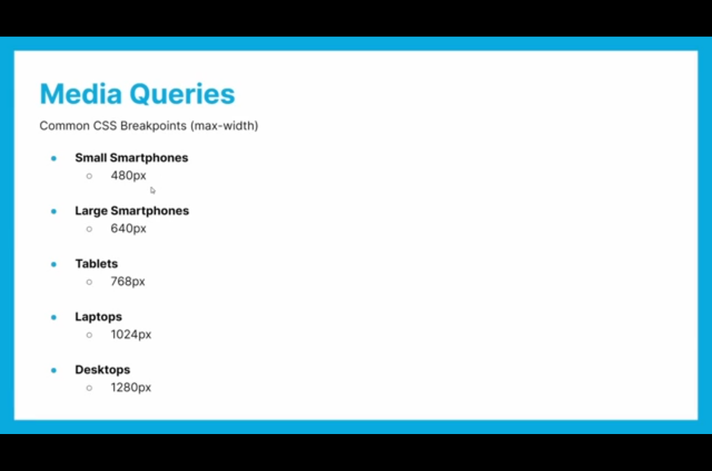
PSEUDO SELECTORS:
- Pseudo-classes: Are keyword added to a selector; they modify the behavior of an element when they are in certain state.
- Pseudo-element: Are keyword added after a selector that’s used to style a specific part of an element. (selector::pseudo-element). There are only two pseudo elements that we need to know about:
- Before: Will put content before our actual element by using the content property.
- After: Will put content after our actual element by using the content property.
CSS just does not like when we do not define the content property at all, it can an empty string for all we care.
ANIMATION:
To use an animation, we need to create an animation using a keyframe rule(@keyfrane then a unique animation name). Within our keyframe there is a few possible values, there is to, from or %. We need to set the animation duration property (how long the animation will take to complete).
TRANSFORM:
This property lets you rotate, scale, skew or otherwise translate an element.
- Translate: The first transformation is translated; we can translate X on the x-axis and Y on the y-axis or both with just translate. Transform: translate (); whatever value you put in the set of parentheses we will translate the element on the x-axis. They can be done with px or %. You can combine both of them with just translate (); but you need two values the translation on the x-axis and then the y-axis.
- Rotations: We can rotate on the x-axis, within the rotateX (); we set a number of degrees. Also, rotateY (); and then rotateZ ();
- Scale: We can scale x and scale y. 1 corresponds to 100%. 1.1 is 110%. Any value below 1 will in a way compress it in that axis.
- Skew: skewX and skewY.
We can add more than one transformation at a time, transform: translateX (100%) rotateZ(90deg) scale (0.5);.
BONUS:
- Shadows: Text and Box Shadows.
  - Text-Shadow: horizontal offset, vertical offset, blur and color.
  - Box-Shadow: horizontal offset, vertical offset, blur and color.
- Float: Allows other elements to flow around it. This is particularly useful with images and block level elements like div sections. Float: left or right, display: flow-root.
- Overflow: Sets the desired behavior when content does not fit in the parent element box. Overflow: [visible, hidden, clip, scroll, auto].
- Background Image: background-image:url (); background-repeat: no repeat; background-position: center; background-attachment: [The background attachment property sets whether a background image scrolls with the rest of the page or if it’s fixed], background-size: cover.
- Pagination: Is a method by which a document is separated into pages, and numbers are given. Usually with pagination, it’s found at the bottom of the web page.
- Font-awesome: fontawesome.com or fonts.google.com.
BEM:
Block Element Modifier is a naming method for writing CSS classes to keep code organized. Naming method: block__element--modifier.
- B – Block (Standalone component): What a standalone component means is basically that doesn’t rely on any other element on a page.
- E – Element (Parts of the block)
- M – Modifier (Variations/Modification of blocks and elements)
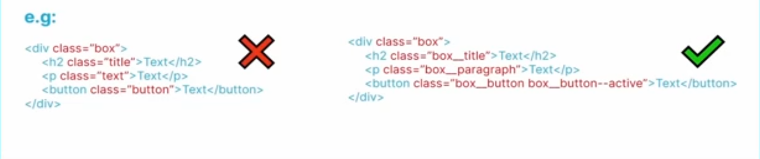
Why don’t we write out CSS classes like the example on the left. Let say you are working in a really large code base as a web developer and you writing class names like the example on the left, its going to make it very hard for other members of your team to figure out what these class names are actually for.
BEM just basically makes our code more organize, readable and easier to work in a team.

